Aspiring Information Designer delivering thoughtful, user-focused design solutions.

Storm Lamp” is a personal 3D rendering project focused on creating a moody and atmospheric scene. Built in Blender, I used procedural texturing and hand-painted details to give the model depth and realism. Careful attention to lighting, rigging, and posing of the background character helped enhance the storytelling and bring the scene to life.

This User Manual was created as part of a university course focused on designing clear, effective instructions for a specific target audience.  
Through user research and thorough usability testing, we identified the audience’s needs and translated them into accessible, easy-to-follow content and visuals. The final design combined clean layouts, intuitive navigation, and clear visual hierarchy, making the manual accessible even for first-time eReader users.

The Time Shift website concept was developed as part of a project to explore the different aspects of web development. Through multiple iterations, the focus lay on both the design and technical implementation, gaining hands-on experience in creating a user-friendly and engaging website. This project not only enhanced my existing development skills but also provided valuable practical knowledge of web design and user experience principles.

Hello! I’m Malte Hermann, an ambitious Information Designer with a broad skill set spanning 3D design and thoughtout user experiences. My goal is to learn, grow, and broaden my horizons through eager participation in your projects.

Hello! I’m Malte Hermann—an Information Designer with a focus on clarity, usability, and engaging experiences.  
My skills bridge the structured world of technical communication with the creativity of 3D and UX design. I’m passionate about making complex information accessible, whether that’s through well-crafted documentation, intuitive interfaces, or visual designs.

Currently, I’m studying Information Design. I draw on my skills in 3D design and user experience to create solutions that are not just informative, but also intuitive and meaningful.

I believe great design isn’t just about how something looks—it’s about how it works, how it guides, and how it helps. I’m eager to keep learning, keep building, and contribute to projects that make a real difference in how people interact with technology and information. Tools:

Ein Bild, das Grafiken, Screenshot, Schrift, Grafikdesign enthält.

Ein Bild, das Grafiken, Schrift, Symbol, Logo enthält.

Ein Bild, das Logo, Grafiken, Symbol, Schrift enthält.

Ein Bild, das Grafiken, Schrift, Symbol, Screenshot enthält.

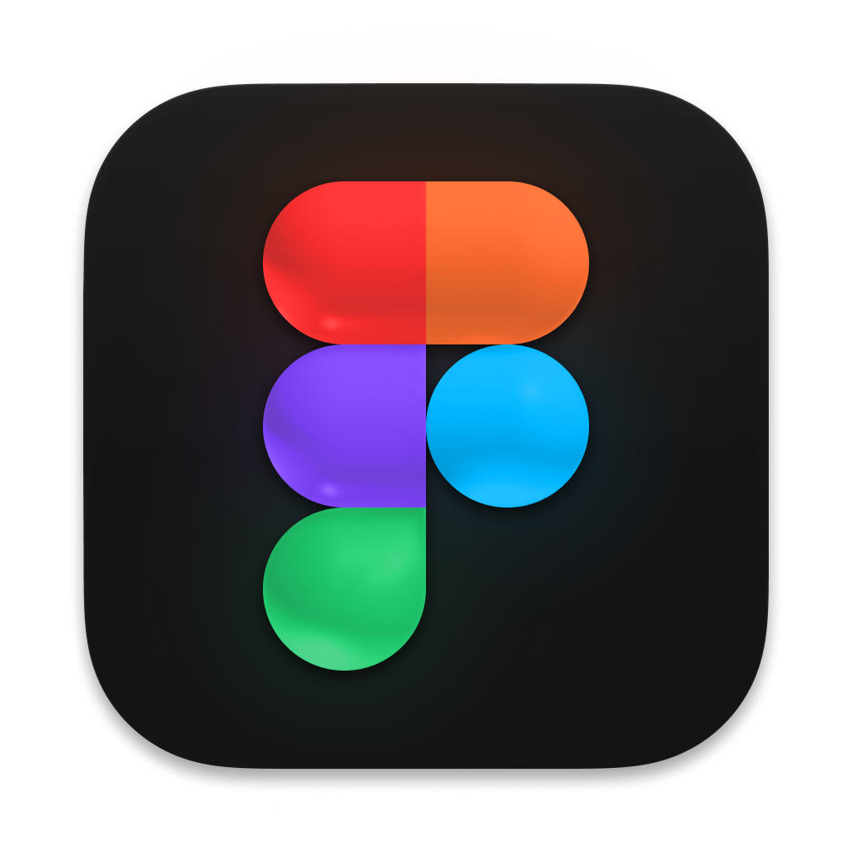

Ein Bild, das Screenshot, Grafiken, Logo, Schrift enthält.

